Name:Nadiifo Abdulahi Mahamed
ID:C6240353
Class: CNS241
SUBJECT: Linux
Assignment Linux
pwd Displays the full path of the current working directory.
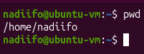
cd Changes the current working directory.
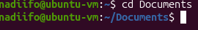
cd ~ Moves to the user's home directory.
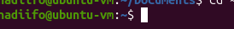
cd ... Moves to the parent directory.
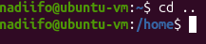
cd. Refers to the current directory.
ls Lists files and directories.
ls -a Lists all files, including hidden files.
ls -l Displays files in a detailed long format.
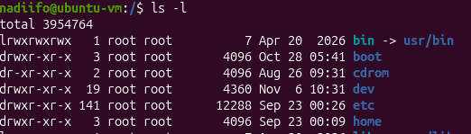
ls -h Displays file sizes in a

ls -lh Displays detailed file information with human-readable sizes.
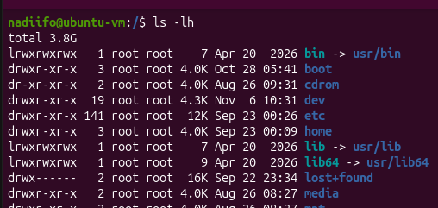
touch Creates an empty file or updates its timestamp.
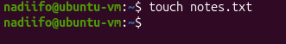
mkdir Creates a new directory.
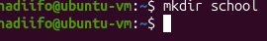
mkdir -p Creates directories, including missing parent directories.

rmdir Removes an empty directory.
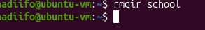
rmdir -p Removes an empty directory and its empty parent directories.
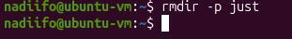
cp Copies files from one location to another.
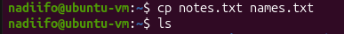
cp -r Copies directories and their contents recursively.
cp -i Asks for confirmation before overwriting a file.

mv Moves or renames files and directories.
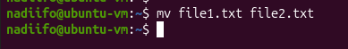
mv -i Asks for confirmation before overwriting a destination.
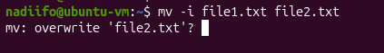
rm Removes files.
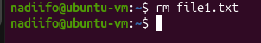
rm -i Asks for confirmation before deleting files.
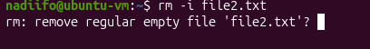
rm -r Removes directories and their contents recursively.
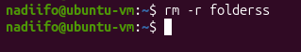
rm -f Forces file removal without asking for confirmation.

man Displays the manual page of a command.
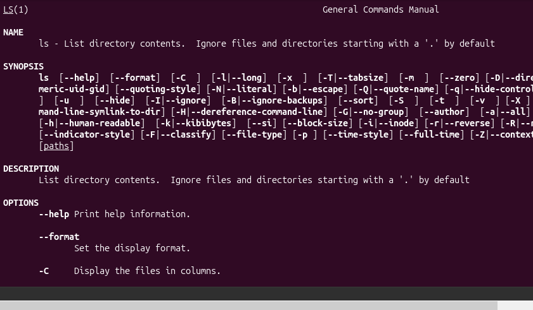
info Displays detailed information about commands and programs.
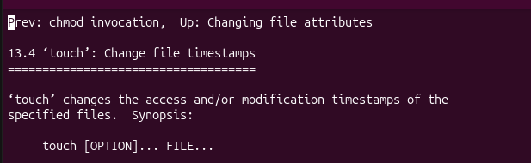
help Displays help information for shell built-in commands.
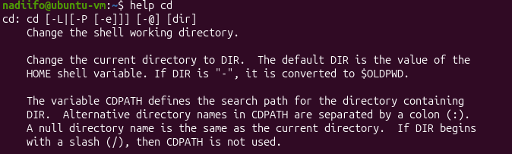
history Displays previously executed commands.
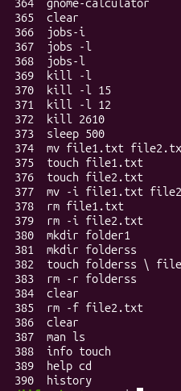
echo Displays text or variable values in the terminal.
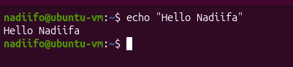
export Exports a shell variable to child processes.
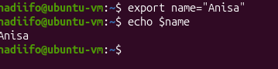
which Displays the location of an executable command.
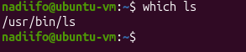
command --help Displays help information and available options for a command.
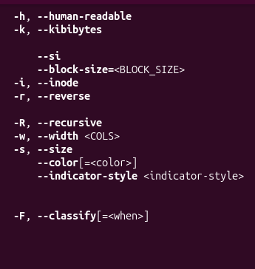
cat Displays the contents of a file. It can also combine multiple files
why student use this command use it when you want read or display file contents quickly.
Syntax cat filename
Option name Description &Example usage
-n Number lines Displays line numbers

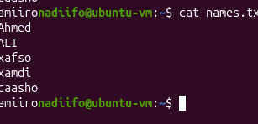
cat -n Displays file contents with line numbers.
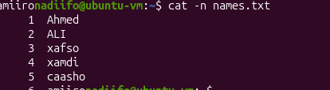
less command displays a file one screen at a time.it allows users to move forward and backward through the file.
Why student use this command
use it to read large files without displaying everything at once.
Syntax less filename
Option and shortcut
shortcut Description &Example usage
Space move to the next page.
b move to the previous page.
/word search for a word.
q quit.

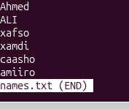
more Displays file contents one screen at a time.
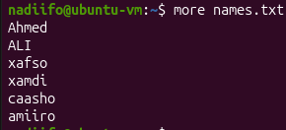
Head command Displays the first lines of a file.by default, it displays the first 10 lines.
Why students use this command
Use it to quickly view the beginning of a file.
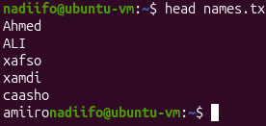
head -n Displays a specified number of lines from the beginning of a file.
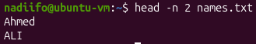
tail command Displays the last lines of a file.by default, it displays the last 10 lines.
Why students use this commands
Use it to view the latest information added to a file.
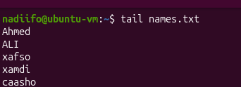
tail -n Displays a specified number of lines from the end of a file.
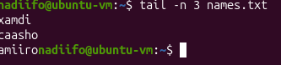
Figure 1hrupo74rufnmhjxvytyhuikoo]p'[\]nj6op5ler69w8e
tail -f continuously displays new lines added to a file.
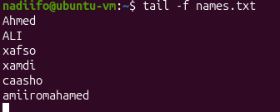
The file command Identifies the type of a file by examining its contents.
Why students use this commands
Use it to identify whether a file is text, an image, a PDF, or another file type.
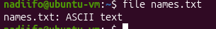
The stat command displays detailed information about a file or directory, including size, permissions, and modification time.
Why students use this commands
Use it when you need detailed file information.
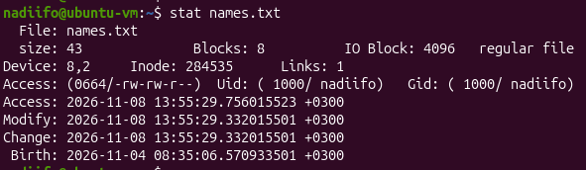
The find command Searches for files and directories in specified location.
Why students use this commands
Use it locate files by name, type, size, or modification time.
find -type f Searches for regular files.
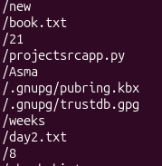
find -type d Searches for directories.
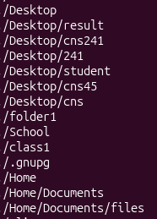
find -size Searches for files based on their size.
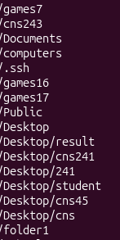
find -mmin Searches for files based on their modification time in minutes.
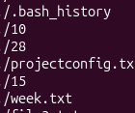
locate command searches for files using a database of file paths.
Why students use this commands
Use it to find files quickly by name
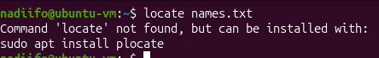
grep command Searches for a specific word or pattern in files and displays matching lines.
Why students use this commands
Use it to find specific information inside a file.

grep -n Displays matching lines with line numbers.
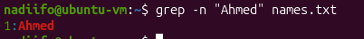
grep -i Searches without considering uppercase or lowercase letters.

grep -v Displays lines that do not match the pattern.
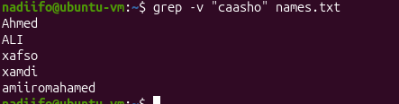
Cut command extracts selected sections fields, or characters from each line of a file.
Why students use this commands
Use it to extract specific information from text or data separated by delimiters.
cut -c Extracts specific characters from each line.
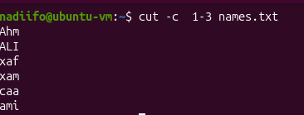
paste command Combines lines from multiple files side by side.
Why students use this commands
Use it to join information from different files
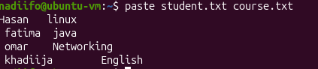
paste -d Uses a specified delimiter when combining files.
wc command Counts lines, words, and bytes and characters in a file.
Why students use this commands
use it to calculate the amount of text in a file.
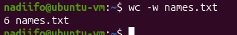
wc -l Counts the number of lines.
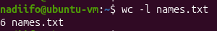
wc -w Counts the number of words.
wc -c Counts the number of bytes.

wc -m Counts the number of characters.

Tr command translates deletes or squeezes characters from standar input.
Why students use this commands
Use it to change lowercase letters to uppercase, delete characters, or replace repeated characters.

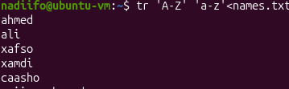
tr -d Deletes specified characters.

